Visual Means for 3D Printer Quality Assessment

Ronald Marsh School of Electrical Engineering and Computer Science University of North Dakota Grand Forks, ND, 58203
rmarsh@cs.und.edu
Md Nurul Amin School of Electrical Engineering and Computer Science University of North Dakota Grand Forks, ND, 58203 m.amin@ndus.edu
Tyler Welander School of Electrical Engineering and Computer Science University of North Dakota Grand Forks, ND, 8203
tyler.welander@und.edu

Abstract

The Department of Computer Science at the University of North Dakota (UND) was funded for one year by the North Dakota Department of Commerce to evaluate optical/imaging methods for measuring the quality of 3D printed parts. In particular, we are interested in optical/imaging methods that can detect and measure such quality issues as layer shifting, layer separation and splitting, overheating, dimensional accuracy, and infill errors. This paper focuses on our work towards the post analysis of 3D printing defects using developed optical/imaging methods. We used a XYZ da Vinci 1.0 3D printer to fabricate the parts and a Logitech Brio 4K webcam to acquire the post-production images. The image processing routines developed compared a known satisfactory part with the part just produced. We initially attempted to capture all images while the parts were still on the printer’s build plate, but that proved challenging due to the printer used. Instead, all images were captured while the part was on a fixed and demarked mount. Use of a green screen background and a red mount simplified the background removal which further simplified the two image comparison. We segmented the images and then, by examining the dimensional accuracy, were able to detect layer shifting and overheating (warpage and tilt) in the parts produced. Splitting, or delamination, was inspected using a neural network and the gray scale images. However, we were not able to detect all levels of delamination using the approach as described. The paper will provide a background on common 3D printing defects, describe the process used to capture the images, the image processing routines developed to detect defects in the parts made, and will provide a brief review of our previously published findings regarding the G-code analysis used to measure the quality of the internal structure of the part being made.

Introduction
The Department of Computer Science at the University of North Dakota (UND) was funded to evaluate optical/imaging methods for measuring the quality of three-dimensional (3D) printed parts. In particular, we were interested in optical/imaging methods that could detect and measure common quality issues encountered when 3D printing.

3D printing is an additive manufacturing process where material is joined or solidified under computer control to create an object [1]. As such, products are produced layer by layer in cross sectional slices [2]. Additive manufacturing is the official industry standard term (ASTM F2792) for all applications of a technology where materials are joined (or added - usually layer by layer) to make objects from 3D model data. Whereas subtractive manufacturing methodologies remove material to make objects from 3D model data. 3D printing is commonly used in producing customized and low production run products. Examples of where 3D printing has been used as a meaningful and reliable way of manufacturing include: replacement parts of machine, prototypes, and medical components. Prototyping, in particular, is an area where 3D printing has multiple advantages: 1) ease of duplicating products, 2) security and privacy consideration of product design, and 3) low cost in customized manufacturing [2].

3D printing was first introduced in 1970 [3] and they work in a way similar to traditional laser or inkjet printers; however, instead of using multi-colored inks, they use filament which slowly builds the piece layer by layer by melting down and depositing the extruded material [2]. Software is used to create thousands of cross-sectional slices of each design to determine which layer is to be constructed and how to construct it. A 3D printer can produce a simple object like a gear in less than an hour [2].

The 3D printing type varies with the materials used. Experiments have been done to produce a versatile range of products like biodegradable materials [4], pharmaceuticals [6, 7], microfluids [9], imaging apertures [5], and nanocomposites [8] all of these have been 3D printed. 3D printing has also been used for preserving historical objects [10] and creating educational excitement [11].

3D printing is an immerging field, as such, we need to be aware of the drawbacks of this technology. Some researchers have found carcinogenic (radioactive) emissions from 3D printed materials when they are melted for printing/extruding [12]; which may have a huge impact on society, but analysis of those impacts is beyond the scope of this paper. Our goal is to determine if we can detect defects in 3D printed objects at the time of printing through image analysis. As a typical 3D printer can’t detect defects in the products, our concern is to provide a mechanism that can operate during the print phase, a mechanism that can detect faults while the part is being printed and eventually be able to then instruct the printer to stop printing (i.e. abandon the part).

For the remainder of this paper we will provide a brief background on 3D printing fault detection, the approach we followed, our results, and our conclusion.

Background

In earlier work, we proposed an approach to evaluate infill quality. To evaluate infill errors, we used both a camera to acquire the images and a computer model of part being made. The intent is to be able to generate a model of the internal structure of the part being made by parsing the G-code (RS-274) layer by layer and then comparing the computer model with an image of the part being generated. As we already published our approach and findings [13] for infill analysis, we will not discuss it further in this publication. In this paper we will provide details as to the processing followed for the analysis of layer shifting, layer separation and splitting, overheating, dimensional accuracy.

To find defects in printed parts, one typically scans the part using a 3D high resolution camera/scanner. 3D scanning is currently used for measuring object shape and size [14], evaluation of products used in reshaping human bodies [15], and in creating custom wear clothing based on body shape [16]. 3D scanning also has many applications in medical science such as in finding defects of a person’s skeletal structure [17], and in validating the quality of automotive products [18] such as turbine blades.

There are a lot of 3D scanning technologies and some are good for short distant scanning, some are better suited for mid or long-range scanning, some are better for small objects, and some are better for large objects like aircraft [19]. Regardless of the type, many 3D scanners use a form of laser triangulation or structured light technology. It is critical that the sensors be located in a known position/distance in order to be able to accurately measure the structure of experimental object. Is such cases, the reflection angel is considered when finding actual points of construction in certain areas. As procurement of a laser-based 3D scanner exceeded the available funding, we instead used a 4k camera to evaluate the shape of finished 3D printed parts. We evaluated the parts with respect to warp, tilt, deformation, and delamination.

There are many different classes of 3D print errors, but we are only interested in a subset of these errors as one of our target applications was that of a leg prosthesis. Specifically, the socket section of a trans-femoral prosthetic leg or above the knee prosthesis. This component tends to be long and hollow. As such, we were only interested in defects such as:

Overheating – where the part becomes overheated and deformed.

Layer Shifting – where layers suddenly misaligned and shift relative to one another.

Warping – where parts warp and/or lean over.

Delamination – where layers separate and split apart.

Slippage – where the part doesn’t stick to the bed and moves during printing.

Dimensional Accuracy - where the measured dimensions do not match the original design intent.

Approach

As noted in the abstract, we used a XYZ printing da Vinci 1.0 3D printer to fabricate the parts and a Logitech Brio 4K webcam to acquire the post-production images. Our first task was to establish the camera to part distance and calibrate the camera to this distance. To do this we made a stepped part of white ABS, acquired pictures and various distances, and selected the distance that generated the best focus and image clarity (Figure 1). Once this distance was determined we measured the part with a caliper and compared the measured dimensions with the pixels in the image (Figure 2).

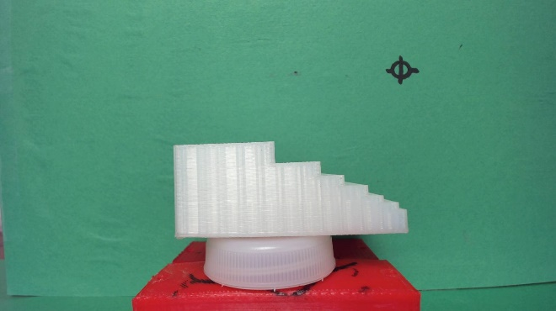

Figure 1: Calibration part.

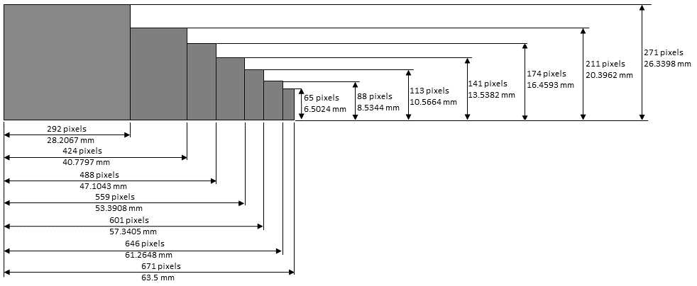

Figure 2: Calibration part measurements.

From this information we determine the vertical and horizontal mm/pixel values. Respectively, these are 0.096049 mm/pixel vertically and 0.095671 mm/pixel horizontally.

As our approach was to compare a known quality part with parts being fabricated it was critical that the camera not move during the data acquisition phase. The fabricated parts were put into a jig for image acquisition which virtually eliminated the possibility of unintended part movement. However, experiments taught us that it was rather difficult to fix the camera such that there would be no change in position. To adjust for this, we applied a Fourier transform matched filter correlation [20] by first creating an alignment pattern (Figure 3) that was in a fixed location in the background. From this pattern, we generated a Binary Phase Only Hartley Filter (BPOHF) [21]. As each image is acquired, the BPOHF is used with the matched filter correlation, along with a correlation peak tracking algorithm [22] to dynamically ensure (and correct) camera alignments.
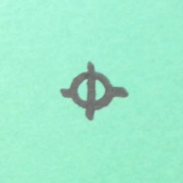

Figure 3: Alignment pattern.
As our approach was to compare a known quality part with parts being fabricated it was critical that the background be removed to make the image comparison more accurate. We found that the background removal was simplified by first converting the images from RGB (red, green, blue) to HSI (hue, saturation, intensity).

Our next step was to de-noise and segment the images. This was done in one step by convolving a 6x6 pixel window over the image. Within the window any pixel less that a dynamically calculated threshold was set to 0, otherwise it was set to 255.

To detect layer shifting and warp similar approaches were applied. In both cases the object/part center was determined for each row of the image. If the differences between the two images resulted on less than 5 rows having a difference in their centers the part was determined to not have any warpage and or layer shift. Otherwise, it was assumed to have some warpage or layer shift. If a part was determined to have such defects, the variance in the center locations and the number of center location differences (greater than 5 pixels) was calculated and the ratio of these was calculated (eq. 1).

$ratio=\frac{variance}{count}$ (1)

If the ratio was greater than 0.5 the part is determined to have some warpage and the angle of the warpage/tilt was calculated (eq 2).

$tilt=\operatorname{atan}\left(\frac{\left(maxV-minV\right)}{\left(maxL-minL\right)}\right)*\frac{180}{PI}$ (2)

Where maxV and maxL are the maximum amount of center to center misalignment and the location (row) of that maximum value, minV and minL are the minimum amount of center to center misalignment and the location (row) of that minimum value.

If the ratio was less/equal than 0.5 the part is determined to have some layer shift and the amount of layer shift is calculated (eq 3).

$shift=maxV*toMmH$ (3)

Where maxV is the maximum amount of center to center misalignment (in pixels) and toMmH is the horizontal conversion of mm to pixels (0.095671 mm/pixel).

To evaluate the parts for overheating, blob analysis was applied by first subtracting the two images (reference part and part being inspected). We then horizontally scanned the resultant image looking for regions left by the subtraction (identical parts would leave no such regions). Each time a pixel was found we performed a flood fill and counted the number of pixels painted during the flood fill. Using the calibration values found, we are able to determine the area of each filled region. We then horizontally and vertically scanned the resultant image to determine the height and width of each region found. This process could also be used for dimensional accuracy testing.

Results
We decided to use a standard shape that was hardcoded into the da Vinci 3D printer. This design was arguably more complex than the type of part we envisioned making, allowing us to stress test the concepts. As most of the code to determine shifted or warped parts was the same, we only need to provide one example to depict each case. Figure 1 depicts a satisfactory part. Figure 2 depicts a part that has significant warp. Figure 3 shows the results of the center line analysis (note the green and red lines indicating the object centers). Table 1 provides analysis details. Examination of Table 1 shows that the part has no apparent shift, but does have about 5.36 degrees of tilt/warpage. As such, due to the tilt/warpage, the part would also appear to have a certain amount of overheating or deformation to the analysis, which is also displayed in Table 1.

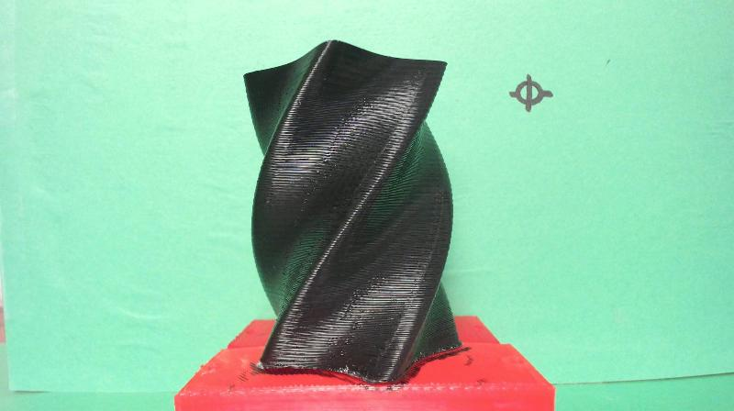
Figure 1. Satisfactory part.

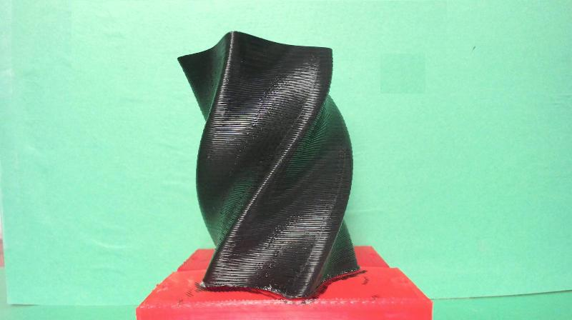
Figure 2. Part with significant tilt/warp.

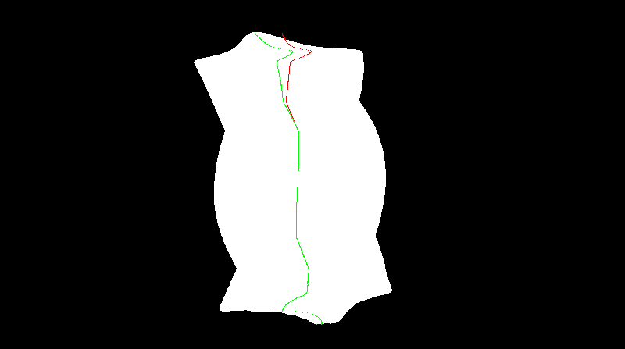
Figure 3. Result of tilt/warp analysis.

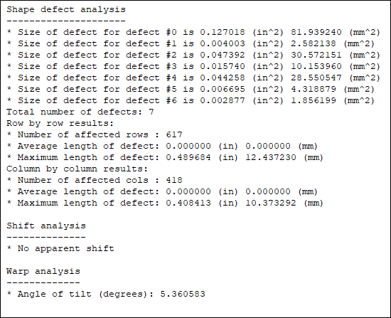
Table 1. Tilted part analysis details.

Figure 4 depicts a part that has significant shift. Figure 5 shows the results of the center line analysis (note the green and red lines indicating the object centers). Table 2 provides analysis details. Examination of Table 2 shows that the part has no apparent tilt/warpage, but does have about 7.46 mm of shift. As such, due to the shift, the part would also appear to have a certain amount of overheating or deformation to the analysis, which is also displayed in Table 2.

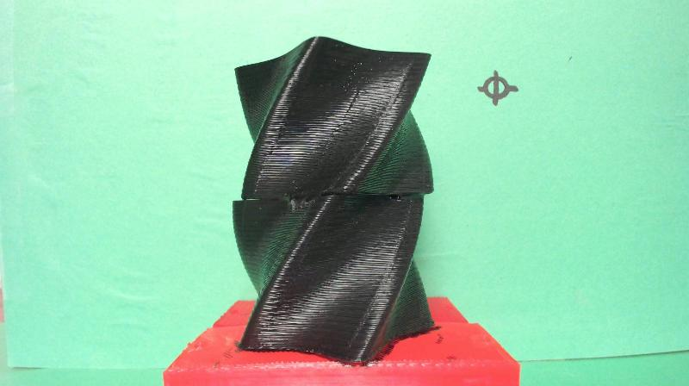
Figure 4. Part with significant shift.

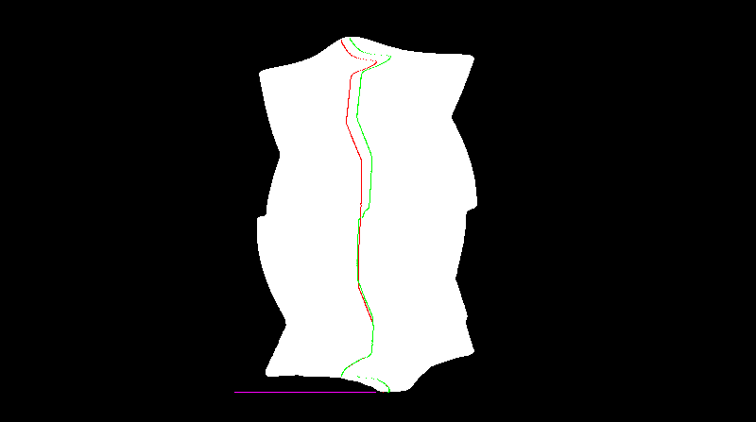
Figure 5. Result of tilt/warp analysis.

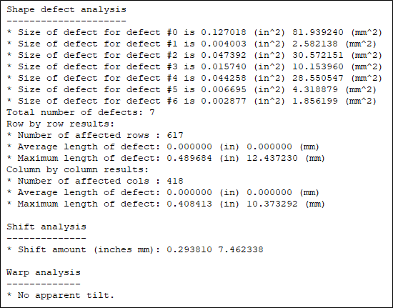
Table 2. Shifted part analysis details.

Figure 6 depicts a part that has significant distortion caused by overheating. Figure 7 shows the results of the blob analysis (note the white areas showing the differences). Table 3 provides analysis details. Examination of Table 3 shows that the part has no apparent tilt/warpage, but does have about 4.03 mm of shift (caused by the deformation). The part also has 8 regions of overheating or deformation.

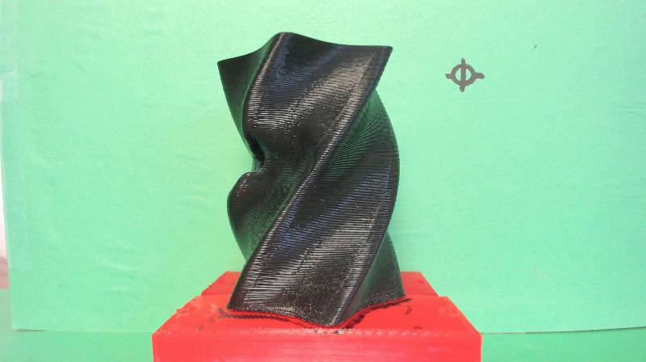
Figure 6. Part with significant distortion

Figure 7. Result of deformation analysis.

Figure 8 depicts a heavily damaged part (it came loose from the base-plate during the print process). Figure 9 shows the results of the analysis (note the white areas showing the differences). Figure 10 shows the results of the tilt/warp analysis (note the green and red lines indicating the object centers). Table 4 provides analysis details. Examination of Table 4 shows that the part has no apparent shift, but does have about 24.94 degrees of tilt/warpage. The part also has a number of large regions of overheating or deformation.

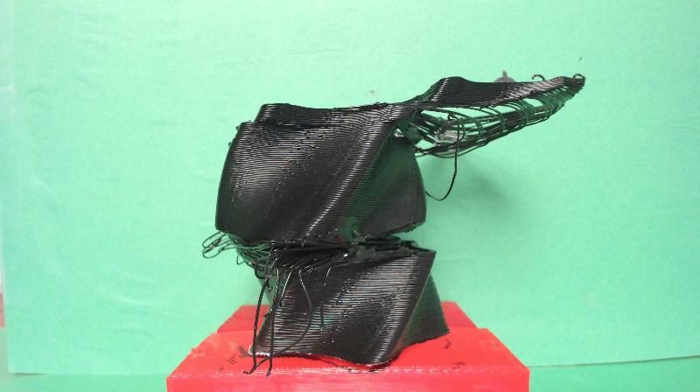
Figure 8. Part with significant damage.

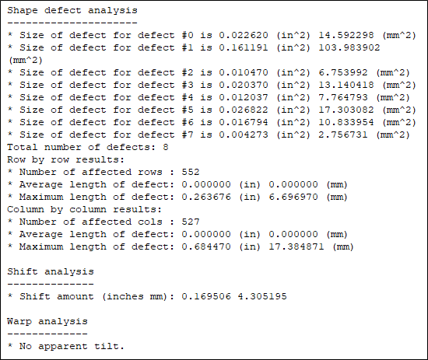
Table 3. Distorted part analysis details.

Figure 9. Result of deformation analysis.

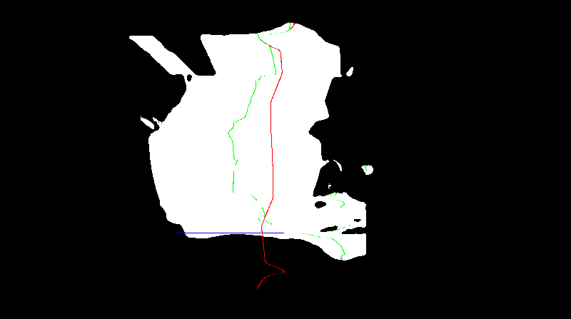
Figure 10. Result of tilt/warp analysis.

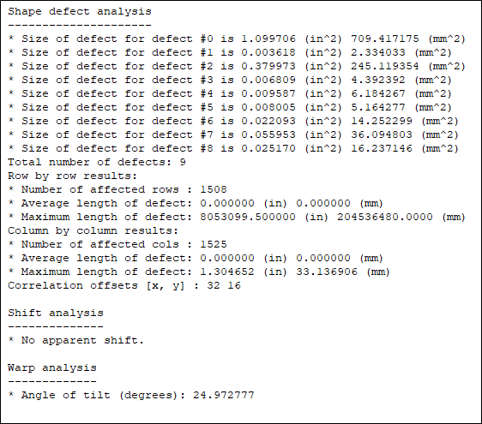
Table 4. Damaged part analysis details.

Conclusion

This paper describes our continuing efforts towards the visual analysis of print errors. We propose a process that can easily detect a number of defects. However, as noted by Straub [23], a number of details would need to be determined based on the intended application. Details such as the number of cameras, camera placement, and background (to ease background removal). The lighting would also need to be thoroughly analyzed.

To conclude, we should note that using the proposed processing, any part that has any shift or warpage will appear to have some deformation. The same can be said for any part that has some deformation as it will appear to have some shift or tilt/warpage. What we do not know, is how much of each (shift, warp, deformation) is acceptable as this would depend on the product being produced. The same would be true for dimensional accuracy.

We did not include examples of delamination as we were unable to generate repeatable results using the single BRIO 4K camera and the lighting configuration we had. A number of lighting configurations were tried, all to no avail. Admittedly, the complex shape of the part we choose did not help as we encountered severe specular reflection no matter what lighting configuration we attempted. This resulted in having some areas under lit and others over lit. Meaning in some areas the camera could not detect any detail and an in some others the camera was saturated, which also resulted in no detail.

Acknowledgements

This work was funded by the North Dakota Department of Commerce award #16-02-J1-114.

References

- Communs, K. The rise of additive manufacturing. The Engineer (accessed on 4 March 2019).
- Berman, B. 3-D printing: The new industrial revolution. Business Horizons. 2012, 55, pp. 155–162.
- Bowyer, A. 3D Printing and Humanity’s First Imperfect Replicator. 3D Printing and Additive Manufacturing. 2014, 1, pp. 4–5.
- Serra, T.; Planell, J.A.; Navarro, M. High-resolution PLA-based composite scaffolds via 3-D printing technology. Acta Biomaterialia. 2013, 9, pp. 5521–5530.
- Miller, B.W.; Moore, J.W.; Barrett, H.H.; Fryé, T.; Adler, S.; Sery, J.; Furenlid, L.R. 3D printing in X-ray and Gamma-Ray Imaging: A novel method for fabricating high-density imaging apertures. Nuclear Instruments and Methods in Physics Research Section A: Accelerators, Spectrometers, Detectors and Associated Equipment. 2011, 659, pp. 262–268.
- Khaled, S.A.; Burley, J.C.; Alexander, M.R.; Roberts, C.J. Desktop 3D printing of controlled release pharmaceutical bilayer tablets. International Journal of Pharmaceutics. 2014, 461, pp. 105–111.
- Sanderson, K. Download a drug, then press print. New Scientist Magazine. 2012, 214, pp. 8–9.
- Campbell, T.A.; Ivanova, O.S. 3D printing of multifunctional nanocomposites. Nano Today 2013, 8, pp. 119–120.
- Bonyár, A.; Sántha, H.; Ring, B.; Varga, M.; Gábor Kovács, J.; Harsányi, G. 3D Rapid Prototyping Technology (RPT) as a powerful tool in microfluidic development. Procedia Engineering. 2010, 5, pp. 291–294.
- Abate, D.; Ciavarella, R.; Furini, G.; Guarnieri, G.; Migliori, S.; Pierattini, S. 3D modeling and remote rendering technique of a high definition cultural heritage artefact. Procedia Computer Science. 2011, 3, pp. 848–852.
- Eisenberg, M. 3D printing for children: What to build next? International Journal of Child-Computer Interaction. 2013, 1, pp. 7–13.
- Stephens, B.; Azimi, P.; El Orch, Z.; Ramos, T. Ultrafine particle emissions from desktop 3D printers. Atmospheric Environment. 2013, 79, pp. 334–339.
- Welander, T.; Marsh, R.; Amin, M. “G-code Modeling for 3D Printer Quality Assessment,” Midwest Instruction and Computing Symposium, Duluth, Mn., April 2018.
- DeMatto, A. 5 Ways Body Scanners Could Make Fitting Rooms Obsolete. Available online: http://www.popularmechanics.com/technology/gadgets/a5909/3d-body scanning-technologyapplications/ (accessed on 13 March 2018).
- Ares, M.; Royo, S.; Vidal, J.; Campderrós, L.; Panyella, D.; Pérez, F.; Vera, S.; Ballester, M.A.G. 3D Scanning System for In-Vivo Imaging of Human Body. Fringe 2013; Springer: Berlin/Heidelberg, Germany, 2014; pp. 899–902.
- King, R. 3D Imaging Spreads to Fashion and Beyond. http://www.hpcwire.com/2008/10/06/3d_imaging_spreads_to_fashion_and_beyond/ (accessed on 13 March 2018).
- Stephan, C.N.; Guyomarc’h, P. Quantification of Perspective-Induced Shape Change of Clavicles at Radiography and 3D Scanning to Assist Human Identification. Journal of Forensic Sciences. 2014, 59, pp. 447–453.
- Voicu, A.; Gheorghe, G.I.; Badita, L. 3D Measuring of Complex Automotive Parts Using Video-Laser Scanning. Available online: http://fsim.valahia.ro/sbmm.html/
docs/2013/mechanics/18_Voicu_2013.pdf (accessed on 1 April 2015).
- ems-usa.com, Types of 3D Scanners and 3D Scanning Technologies. Available online: https://www.ems-usa.com/tech-papers/3D%20Scanning%20Technologies%20.pdf (accessed on 13 March 2018).
- VanderLugt, A. Signal detection by complex spatial filtering. IEEE Transactions on
Information Theory, vol. 10, pp. 139-145, 1964.
- Cottrell, D. M.; Lilly, R. A.; Davis, J. A.; Day, T. Optical Correlator Performance of Binary Phase-only Filter using Fourier and Hartley Transforms. Applied Optics, Vol. 26, No. 18, 1987. pg. 3755-3760.
- Marsh, R. Correlation Peak Tracking Algorithm, United States Patent & Trademark Office: Notice of Allowance. 1992.
- Straub, J. Initial work on the Characterization of Additive manufacturing (3D Printing) Using Software Image Analysis. Machines. 3, 2015. pg. 55-71.

